

OCTOBER 2007

PRESIDENT’S MESSAGE

Dear Brothers and Sisters:

What wonderful weather we have been enjoying; warm days and cool nights are a sure sign of fall.

Sunday, Sept. 16, was the first Grand Council meeting in Richmond with our newly elected State President, Josephine Nunnenkamp, presiding. It was a very informative meeting, and one of the subjects talked about was the OSIA archives located at the University of Minnesota. In the forthcoming issue of Il Giornale, there is a very nice article written by Mary Ann Canale, who visited the archives this summer. If you have any pictures, articles or interesting stories that you think might be of interest, get in touch with the State Historian, Omero Sabatini. This is the history of OSIA from the beginning, and we need to keep updating it.

The Wine Festival with an Italian Accent –Festa Vine Di San Gennaro—is coming on October 13 at Reston Town Center. Our lodge, thanks to Susan Agosta, will be having a booth and selling small items, key chains, napkins, magnets, etc. If you would like to volunteer, you will get in free and have access to the hospitality tent. Volunteers are needed in all areas so contact Bob Maida at bob631@aol.com. This will be a day of celebration with Italian culture, cooking, bocce, language and briscola lessons along with music. Please plan to attend. Look for the flier in the newsletter.

Our next general membership meeting is Sat, October 20, at the KofC Hall. Our speaker is Dr. Tom Bottegal, and his topic is genealogy—something that should interest everyone. The dinner is pot luck as usual. Please remember that you are to bring enough food for your family plus 4 more.

The Williamsburg bus trip has been cancelled due to lack of interest. Susan may try again in the spring with another type of trip. Stay tuned!!

The Lunch Bunch will meet on Tuesday, Oct. 9, at Paradiso Restaurant on Franconia Rd at 12 Noon. There is a buffet--$16 with beverage (soda, tea and coffee)--$14 with water only. Please make your reservations with Joe Saia by Mon. Oct 8 (dmjcs@cox.net).

We welcome new members: Fran Mazarella, Maria Teresa Chico and Henry Colletto. Please make them feel welcome. At the Sept. meeting, the 50/50 was won by Tony Finocchiaro. At our November meeting, we will begin collecting for our Christmas family. Beware the ghosts and goblins.

Fraternally,

Dot

ITALIAN HERITAGE LODGE 2517 - OFFICERS

President Dot Saia Lodge Trustees
703 978 8499 dmjcs@Cox.Net Janine Andriole -- Bob Maida
Vice-President Joe LaMarca Joe Ganci -- Phil Traina
703 475 6962 Jlamarca@Erols.Com Yolanda Pelosi
Imm Past President Omero Sabatini Master/Mistress of Ceremonies
703 931 5054 Sabakiko72@Comcast.Net John Dovel
Orator Frank Marcinkowski Sr. Ivana Ganci
703 323 8447 FMarcinkow@AOL.Com Sentinel – Victor Haburchak
Recording Secy Dolores Marcinkowski Membership Chair:
703 323 8447 FMarcinkow@AOL.Com Bob Maida (Bob631@AOL.com)
Financial Secy Jo Lowe Members on the Grand Lodge
703 449 0682 Lowejs@AOL.Com Jo Vidiri Nunnenkamp – President
Treasurer Gene LaColla 703 893 4270
703 246 9464 Gino4one@AOL.Com Omero Sabatini, Trustee (703 931 5054)
Sabakiko72@Comcast.Net

La Bandiera Editor:

Paul Alligood, 703 848 1758 - Palli14145@AOL.Com, 1908 Youngblood St., McLean, Va. 22101

Visit our lodge website at WWW.ITALIANHERITAGELODGE.ORG (upper case added for emphasis – not required on the address line). Check the website for breaking news between newsletter editions.

FUTURE LODGE EVENTS

October 10 Council Meeting 7:00PM AT KofC

October 13 San Gennaro Festival 11:00-9:00 Reston Town Center

October 20 Lodge Meeting 7:00PM AT KofC

November 10 Lodge Meeting 7:00PM AT KofC

November 14 Council Meeting 7:00PM AT KofC

LODGE MEETING OCTOBER 20

Our program is “Tracing Italian Ancestry” and will feature Dr. Tom Bottegal who is a member of the OSIA Washington, D. C. International Lodge where he did a very successful presentation on this topic. Come and learn! The dinner is potluck; the social starts at 7:00. Hope to see you there!


LODGE ANNOUNCEMENTS

The LUNCH BUNCH will meet on Tuesday, Oct. 9, at Paradiso Restaurant on Franconia Rd. at noon. Come one come all. Call Joe Saia (703 978 8499) for directions and reservations. A buffet is featured at a cost of $16 with beverage (soda, tea and coffee) or $14 with water only.

We welcome Audreenia DeFranks as our Lodge State Deputy. We hope to see her (and Carmen) at many of our functions.

The Italian Cultural Society of Washington holds its social meetings at 3PM on Sundays at the Friendship Heights Village Center, 4433 South Park Ave., Chevy Chase, Md. You can call the Society for further details at 301 656 2797.

Check the website, italianheritagelodge.org. It now has pictures and is updated frequently.

OCTOBER BIRTHDAYS

Paul Nunnenkamp Oct. 4 Paul Alligood Oct. 13
Laura Asiello Oct. 6 Debra Wright Oct. 19
Kevin Brady Oct. 8 George Asiello Oct. 26

Caroline Hartzler Oct. 9

OCTOBER ANNIVERSARIES

Art & Gloria Moscatello Oct. 2
Frank & Susan Bonsiero Oct. 6
Frank & Patricia Marcinkowski, Jr. Oct. 6
Joe & June LaMarca Oct. 6
George & Beth Asiello Oct. 10
David & Laura Strong Oct. 18

CONCERNS AND PRAYERS

Millie Malm


Marge Finocchiaro

Tricia Marcinkowski

John Dovel who is recovering from a broken leg

ITALIAN LANGUAGE LEARNING GROUP MEETING

The next meeting of our combined Italian language conversation group will be at 6PM on Saturday, October 6, at the home of Frances Mazarella. As always, all are welcome regardless of Italian language proficiency. Please contact Betsy Mignani at mignani@cox.net, (703 830 7699), and let her know which food item you plan to bring for the meal. Directions to the meeting site can be provided.

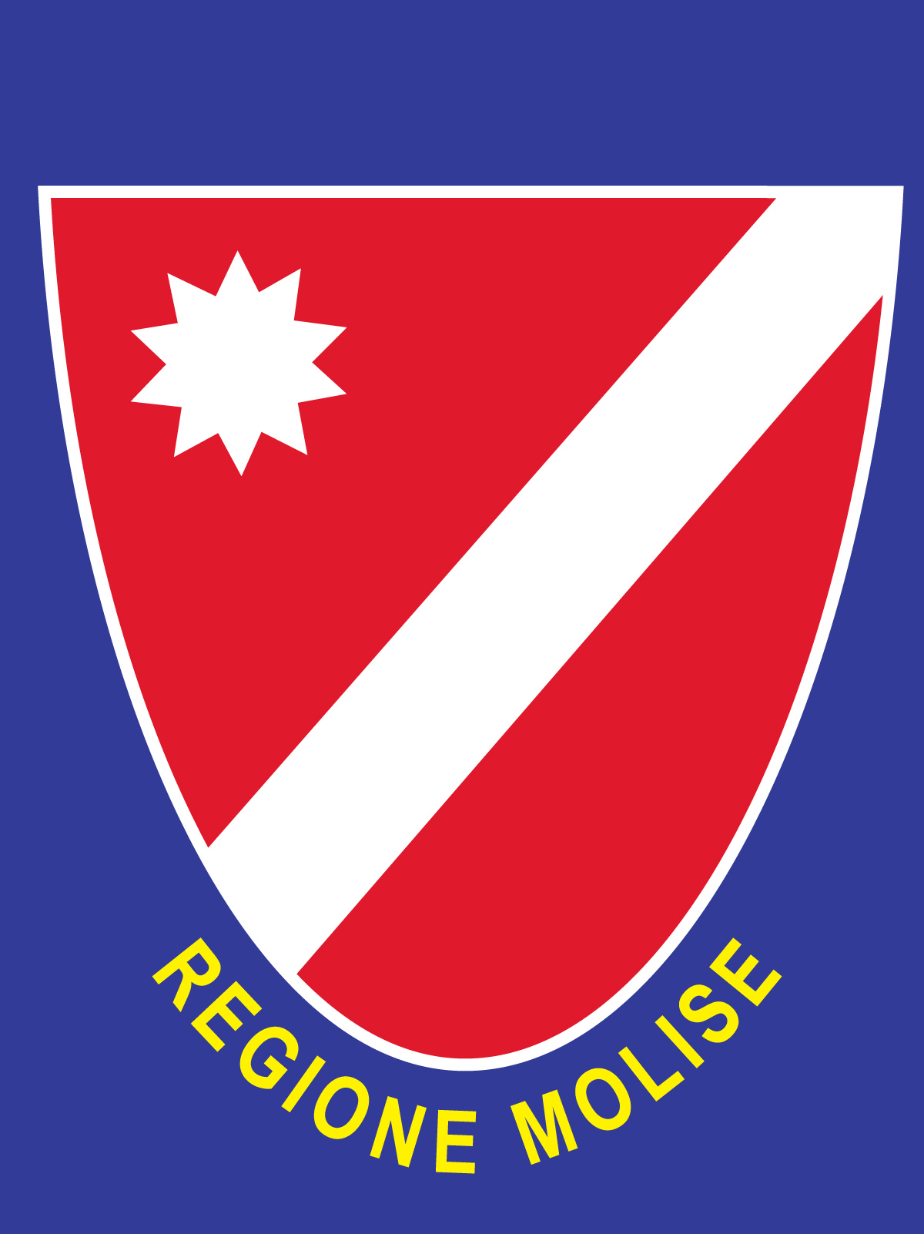
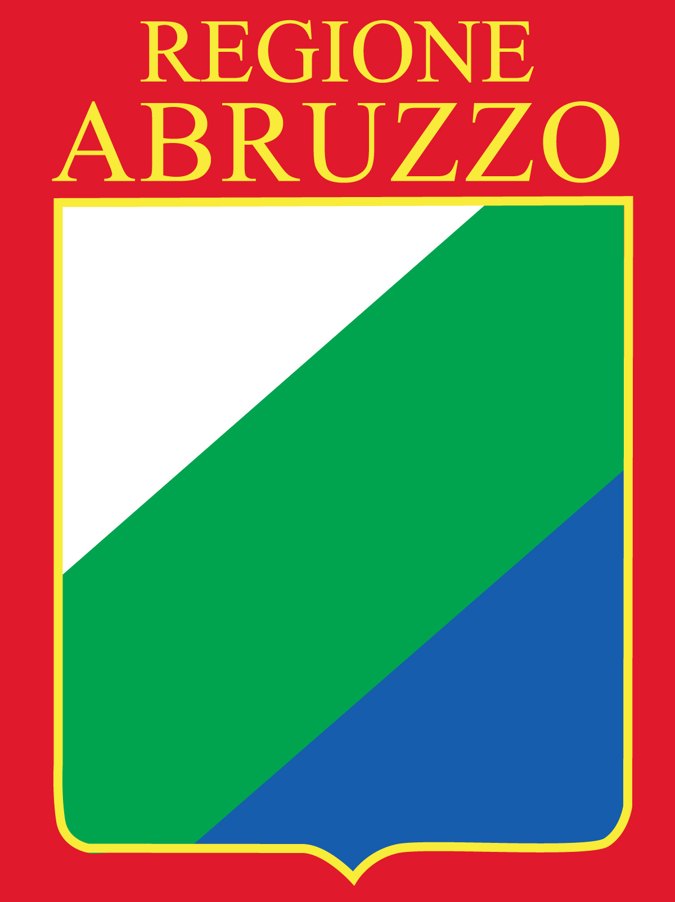
The
Abruzzo and Molise
Heritage Society

Presents… Directly from Italy…

LA COMPAGNIA DI TEATRO SPERIMENTALE
‘Renato Bevilacqua’

IN: “PENSIONE DELLA TRANQUILLITÀ”
A delightful two act comedy play, in Italian
Directed by: Angelo Pagano

In the USDA Thomas Jefferson Memorial Auditorium, Washington DC The performance will be followed by a light dinner reception on site

When: Friday October 5, 2007
6:30 – 8:30 PM
Reception: to follow

Where: Jefferson Auditorium,
US Dept. of Agriculture
1400 Independence Ave SW
(personal ID required to enter)

Price: FREE

For information call: Ennio DiTullio 703-785-8247, Maria D’Andrea 703-998-6097 or Tony D’Onofrio 301-570-9214

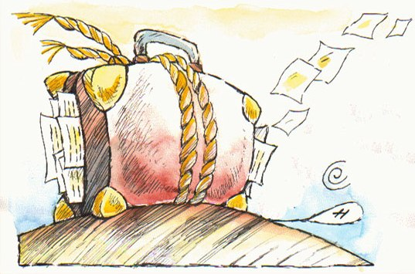

PLEASE NOTE THAT THIS EVENT IS FREE OF CHARGE. Ennio Di Tullio, President of the AMHS, hopes IHL members can attend and promote the play with friends and family members. He notes that it is a unique opportunity to showcase this delightful, regional comedy and to help in the preservation of our Italian traditions.

.



Volunteers Needed

Dear Lodge Presidents:

The San Gennaro Foundation of Virginia is looking for Volunteers to assist with their First Annual Festa Vino di San Gennaro.

Here are the particulars:

Date: October 13
Time: 11:00 am to 9 pm
Place: Reston Town Center
Jobs: Money Takers
ID Check
Wine Glass Distribution
Hospitality Tent
Children’s Area
Bocce Tournament
San Gennaro Procession

Benefits: Free Admission to Event (there will be a cost to sample wine at winery booths)
Free Souvenir Wine Glass
Access to Hospitality Tent with free food and beverages
Satisfaction!

Sincerely,
Laura Frappollo
SGFVA Secretary

If you are not a volunteer, adult admission is $20 in advance or $25 on site and includes a souvenir glass, unlimited samples, live music and cooking and wine demos. Designated drivers are available for $10. Kids 12 and under are FREE! Call 800-830-3976 to purchase tickets in advance.

This is a unique wine festival accented by a celebration of Italian culture. Treat your taste buds to an array of the finest Italian and international wines as well as local wine from Virginia wineries; over 150 wines available for sampling;

Great live music all day featuring the spectacular John Signorello and his 11 piece orchestra;

Bring the kids – fabulous kids area on site with crafts, games and prizes;

There will be wine and cooking demos with your favorite local chefs and wine educators

The San Gennaro Foundation of Virginia is a non-profit organization established to uphold the principles of San Gennaro, the patron saint of Naples, Italy, who worked tirelessly throughout his life to help people in need through acts of generosity and goodwill that define the Italian spirit. The organization is also dedicated to the preservation and promotion of Italian traditions, culture, music, and art.

CHRISTOPHER COLUMBUS AND THE START OF THE AGE OF DISCOVERY

In my view, our Lodge could not be rightfully named Italian Heritage if the October issue of its newsletter failed to make any reference to Cristoforo Colombo or, as we say over here, Christopher Columbus. Thus, here are some thoughts for the day.
President Kennedy once remarked that the truly great personages of history are readily identified and remembered -- long after their death -- by a one-liner: he freed the slaves; he is the Father of our country; he wrote the Declaration of Independence; she was known as the Virgin Queen [rightly or wrongly, I might add]; and, he is the greatest poet of the English-speaking world. Well, say, “He discovered a new world,” and see whose name comes immediately to mind.
But Columbus did more than discover a New World. By sailing to and exploring a few
islands off the vastness of the Americas, he proved that the earth was round and set in motion the Western World's most fateful chain of events since the birth of Christ. He paved the way (waves?) for other glorious, if less adventurous, Italian explorers (Amerigo Vespucci, of course, but also Giovanni da Verrazano and Giovanni Caboto, or John Cabot); far more importantly, Columbus made it possible for another Italian, Galileo, to argue and ultimately prove that earth was not the center of the universe.
It goes without saying that if planet earth is not the center of the universe, then one has to try to find out what really is out there -- in that vastness of space far, far, far greater than the vastness of the Americas that Columbus did not even get to see.
Surely, Columbus and Galileo started people wondering about and trying to explore the galaxies, but would space exploration, i.e., the new age of discovery, have been possible without wireless communication? And who is the inventor of wireless communication? Another Italian, of course, none other than Guglielmo Marconi. I suppose that at least some of you have seen the small but graceful monument erected to him somewhere on Wisconsin Avenue in the District, but must confess that when I am pestered by these now ubiquitous cellular phones, or by some of the music that I hear blaring out from other peoples’ car radios, I am not always so proud of our own Marconi's invention. But, then, one takes the good with the bad. Happy Columbus Day and Happy Discovery Day to all of you. Ciao a tutti
Omero Sabatini



