

MARCH 2013

PRESIDENT’S MESSAGE

Cari amici,

Spring is fast approaching, and we look forward to the blossoming of the flowers and the leafing of the trees. In Agrigento, Sicily, the people celebrate the arrival of spring with Il Festival del Mandorlo, the week-long almond blossom festival. The Valley of the Temples (a site of several ancient, well-preserved Greek temples) is filled with almond blossoms in April. The festival draws both local inhabitants and tourists from all over the world who savor both the beauty of the flowers and enjoy the pleasures of local food specialties, wine, and entertainment.

Restaurants in the area offer special menus based on the almond including dolce and other courses. Sicilian wine is plentiful and entertainment is provided by folkloricmusicians and dancers from all over the globe. The festival begins with a ceremony celebrating friendship across the world in which representatives of all the nations that participate in the festival gather in front of the Temple of Concord. There are also acrobats, flag troops, and tambourine players who stroll the streets and a photography exhibit of the history of Agrigento and the festival.

Il Festival del Mandorlo began in 1934 in Nasco, a little town in the province of Agrigento. There are two versions of the origin of the festival. In the first, Count Alfonso Gaetani wanted to celebrate the arrival of spring and give the peasants on his land a day off from work devoted to merry-making. In the second version, the chief motive of the event was the promotion of Sicilian products. The festival was later moved from Nasco to the city of Agrigento to encourage wider attendance. In any case, the almond festival has become a much loved harbinger of spring to Sicilians.

This month, our new executive council members will be installed as your leadership team. The team, led by Dennis Lillo, president, and Sal Guli, vice-president, will make this coming year for the lodge an excellent one. Congratulations and best wishes to the entire incoming executive council. Please join us at the installation of officers on Sunday, March 3. Details of time and place were described in the February newsletter and are noted in this newsletter.

I very much appreciate the guidance, support, encouragement, and hard work of the executive council this past year in my term as president. Grazie mille to each of you.

A presto,

Anne

ITALIAN HERITAGE LODGE 2517 – OFFICERS

President Dennis Lillo Lodge Trustees
703 354 2454 Delillo1(at)Verizon.Net Kevin Brady----Lucio D’Andrea
Vice-President Sal Guli Jo Lowe----Victor Haburchak
703 321 9552 Salguli(at)Cox.Net Fred Michaelangelo
Imm Past-President Anne Marrelli Master/Mistress of Ceremonies
703 385 0814 Anne.Marrelli(at)gmail.com Paul Alligood
Orator Dot Saia Rosalie Ciccotelli
703 978 8499 Dmjcs(at)Cox.Net Sentinel ---- Bruno Diconi
Recording Secy Eleanor Lillo Membership Chair:
703 354 2454 Delillo1(at)Verizon.Net John Asiello (jfasiello(at)AOL.Com)
Financial Secy Laura Strong 703 321 7840
703 436 4299 Laura.Strong(at)us.army.mil Education Chair:
Treasurer Gene La Colla Art Moscatello (ArthurMoscatello(at)
703 246 9464 Gino4one(at)AOL.Com Comcast.Net)
Members on the Grand Lodge Publicity Chair: Joe La Marca
Susan Agosta McFetridge – Trustee (Jlamarca(at)erols.com)
(smcfetridge(at)caci.com) 703 455 0376

La Bandiera Editor:

Paul Alligood, 703 848 1758 – Palli14145@AOL.Com, 1908 Youngblood St., McLean, Va. 22101

Visit our lodge website at WWW.ITALIANHERITAGELODGE.ORG. Check the website for breaking news between newsletter editions.

FUTURE LODGE EVENTS

Mar. 3 Officers’ Installation Brunch 12:00 Noon Ft. Myer NCO Club

Mar. 19 Lunch Bunch 12:00 Noon Villa Bella Rest.

Mar. 20 Council Meeting 7:00 PM Fairfax Library

Mar. 23 Language Group 6:00 PM At The Mignani’s

April 6 Lodge Meeting TBA TBA



LODGE ANNOUNCEMENTS

The Lunch Bunch will meet next on Thursday, March 19th, at the Villa Bella Restaurant in Burke, VA. It is located at 6050 Burke Commons RD., off of Burke Lake Pkwy near Burke Lake Rd. They have many fine Italian entrees, sandwiches, pizza and appetizers that should provide you with a variety of lunch options. Hope to see many of you there. Please contact Dennis Lillo at delillo1@verizon.net or call at 703-354-2454 if you are planning on to attend so he can make the appropriate reservation.

Lodge member Peter Ognibene has an article in the Winter issue of “Italian American” magazine. It’s titled “Lorenzo Da Ponte: Life as Opera.” Check it out.

The language group will meet March 23 at Carlo and Betsy Mignani’s home at 6:00 PM. Please advise Carlo and Betsy (Mignani(at)cox.net) what you plan to provide for the meal. All lodge members are welcome.

MARCH BIRTHDAYS

David DiQuollo Mar. 6 Linda Carullo Mar. 25
Rosalie Alligood Mar. 13 Angelo Vecchio Mar. 26
Dolores Marcinkowski Mar. 18 Lucio D’Andrea Mar. 28
Carol La Colla Mar. 20



MARCH ANNIVERSARIES

NONE

LODGE DUES INCREASE APPROVED

Lodge members attending the general membership meeting on Feb. 9 voted to increase lodge membership dues $5 per member, that is, $35 for the first member and $30 for the second member of the same household. The increase goes into effect April 1.

LODGE MEETING IN APRIL
The April lodge meeting will be replaced by a concert of music on Saturday, April 6, by Italian composers including Domenico Scarlatti, Frederico Busoni, Francesco Veracini, Giulio Bricialdi, and Alfred Casella. The concert will be performed by professional musicians Robert Kelly, pianist, and Susan Hayes, flutist. Refreshments will follow the concert. The time and place of the concert will be forthcoming. When those are firmed up, a message will be sent to all lodge members.

JOINT INSTALLATION OF OFFICERS & BRUNCH
MARCH 3, 2013
GEORGE WASHINGTON LODGE – ITALIAN HERITAGE LODGE

This event takes the place of our regular general membership meeting for March and will be held at the Fort Myer NCO Club (Spates Hall). The social starts at 12:00, brunch is at 12:30, the ceremony begins at 1:45 and concludes at 2:30 and the post social ends at 3:00. The cost is $20.00 per person and includes tax, gratuity and the following:

MENU: Waffle Station Omelet Station
Salad Bar Fresh Fruit
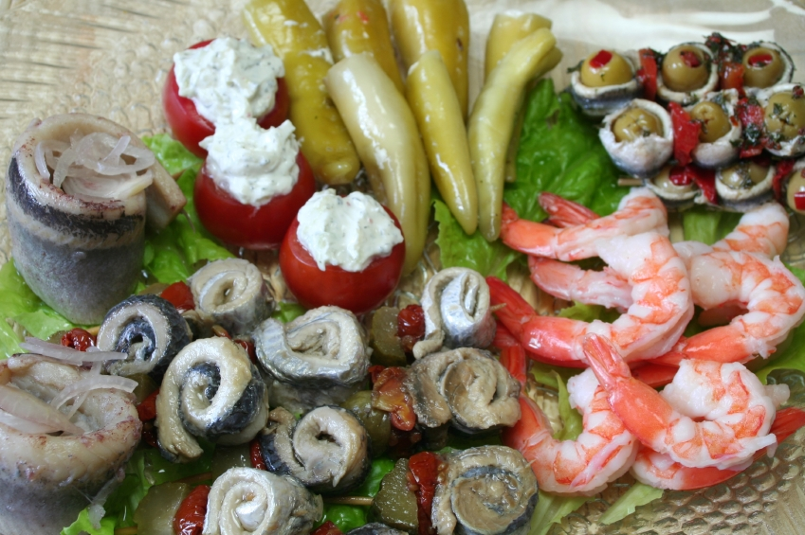
Smoked Salmon Scrambled Eggs
Bacon Strips Sausage Links
Baked Ham/Pineapple Sauce Beef au Jour
Cream Beef/Biscuit Fish
Rice Pilaf Chicken
Potatoes Vegetables
Danish Bagel
Muffins Biscuits
Desserts: Assorted pies and cakes

Beverages: Orange Juice and Coffee

Bar Drinks: Cash bar at your expense; NO FREE CHAMPAGNE

RSVP: IHL Members to Gene La Colla – 703 246 9464 or Gino4One(at)Aol.Com

Directions to Fort Myer

FROM THE SOUTH FROM THE WEST
Head North on I-395 Head East on Route 50
Exit onto Washington Blvd. North By the Iwo Jima Memorial
(Following Signs to Ft. Myer) Follow signs to Ft. Myer
Exit Wash Blvd at ramp to Ft. Myer Entering the Wright Gate
Entering at Hatfield Gate

ALL ADULTS MUST HAVE A PHOTO ID TO ENTER FT. MYER

Follow directions of Gate Guard Follow Directions of Gate Guard
Ask Gate Guard for Directions to SPATES HALL Ask Directions to SPATES HALL
PX is on the left and Chapel is straight ahead Take Marshall Drive to McNair Rd.
Turn left in front of chapel onto McNair Rd. Spates Hall is on the right and
Spates Hall is on the left and parking is on the right parking is on the left



Grand Lodge of Virginia
Order Sons of Italy in America
33rd Biennial Convention – May17 - 18, 2013
Registration Form

Name(s): ______________________________________________________________________________

Address: ____________________________________________________________________________

City: ____________________________________________ State: ________ Zip Code: ____________

Telephone #: _____________________ E-mail Address: ______________________________________
(Please print legibly)
Lodge: ______________________________________________________________________________

Arrival Date: __________________________

If you have any questions please call State President, Marie Siebeking at (757) 481-4030 # People Total
Convention Registration Fee (per person): $130.00 _______ $_______

(Includes: Thursday night Hospitality Suite, Friday night Dinner at Roma Lodge,
Breakfast & lunch on Saturday plus the Banquet on Saturday evening at the Hotel;
plus all documents, credentials, and convention materials.)

Make checks payable to Roma Lodge #254 and mail to:
Paul Siebeking, 2833 Charlemagne Drive, Virginia Beach, VA 23451

Please check the Committee Meeting you will attend Friday afternoon (you will be assigned, if you do not chose):

Audit/Budget ___Bylaws __ Charity __ Culture & Heritage ___ Education __ Fundraising __ Good of the Order __ Membership __

Registration deadline is March 17, 2013.

Hotel Information

Springhill Suites by Marriott
6350 Newtown Road
Norfolk, VA 23502

Telephone: Call (757) 333-3100 or toll free (888) 287-9400 to make your reservation. Please notify the reservations agent that you are with the Sons of Italy Group. The hotel rate is $111.00 (Plus City and State tax).

Hotel registration deadline is May 5, 2013.
Grand Lodge of Virginia
Order Sons of Italy in America
33rd Biennial Grand Convention

May 17-18, 2013

Program Booklet Advertising Rates

PLEASE PRINT CLEARLY

Name: _______________________________________________________

Address:______________________________________________________

City: _____________________________ State: ___________ Zip Code: ________

Telephone Number: ____________________ E-Mail:____________________________

□ Full Page $100.00 □ Half-Page $50.00

□ Quarter Page $25.00 □ $10 Patron or Memorial ________________________
(Name)

(CHECK APPLICABLE CATEGORY ABOVE)

Individual Lodges will be provided signature pages to sell space at $1.00 per Signature with a Minimum of 25 signatures per page to be returned with the money NLT the Deadline date.

Deadline is April 2, 2013

PLEASE EMAIL YOUR AD FILE (WORD/PDF/JPEG) TO:

homerunsigns@cox.net

HARD COPIES (EXCEPT FOR SIGNATURE PAGES)
WILL NOT BE ACCEPTED

Please send all checks (made payable to Roma Lodge #254) (memo Convention Ad) to:

John William Del Russo, Sr.

5469 Albright Drive
Virginia Beach VA 23464



