

JUNE 2014

PRESIDENT’S MESSAGE

Cari amici,

Unfortunately, I was unable to attend the May 3 presentation on the Puglia region of Italy due to a medical issue. Luckily it turned out to be a false alarm, but I appreciate the concern and well-wishes expressed by many IHL members.

Thanks to John Asiello for the flowers presented to our members in appreciation of Mothers Day and to the men who took the time to provide the food for the pot luck. At our May board meeting, I was informed that the presentation on Puglia was well-received and that it was accompanied by a second presentation on the art of mosaics that was very informative. If any of you know of individuals who could inform us on other regions of Italy or Italian cultural or artistic subjects, please let us know so we may have them for a future monthly meeting. Send me suggestions by email delillo1@verizon.net or call me at 703-354-2454.

Gene La Colla is putting the finishing touches on our catered dinner to be held on June 14. Details for this event are contained inside this newsletter. Please remember to RSVP as requested as it is important for us to know how many will be attending so we can order the appropriate amount of food. There will be no charge for wine or soda that night, and the desserts will be provided from IHL funds. And remember to bring in baby pictures of yourselves for the baby naming contest that we will hold that evening.

Planning for our participation in the Fairfax County Fourth of July parade is underway. Please plan to join your fellow IHL members as we celebrate our nation's birthday and the many contributions made by Italian Americans. For those who may not want to walk the mile and a half route, there will be an opportunity to ride in a vehicle. In August, we will have our traditional peach picking outing followed by a luncheon at the Blackthorne Inn. Also in August we will have our annual IHL picnic. The date was moved from September due to Knights of Columbus Hall availability. Details can be found in this and future newsletters.

A Presto,

Dennis

ITALIAN HERITAGE LODGE 2517 – OFFICERS

President Dennis Lillo Lodge Trustees
703 354 2454 Delillo1(at)Verizon.Net Rosalie Ciccotelli----John Dovel
Vice-President Sal Guli Marianne Hallihan----Anthony Musco
703 321 9552 Salguli(at)Cox.Net Joe Onofrietti
Imm Past-President Frank Marcinkowski Master/Mistress of Ceremonies
703 323 8447 Fmarcinkow(at)Verizon.net Paul Alligood
Orator Dot Saia Renee Signorelli
703 978 8499 Dmjcs(at)Cox.Net Sentinel ---- Kevin Brady
Recording Secy Eleanor Lillo Membership Chair:
703 354 2454 Delillo1(at)Verizon.Net John Asiello (jfasiello(at)AOL.Com)
Financial Secy Jo Lowe 703 321 7840
Lowejs(at)aol.com Education Chair:
Treasurer Laura Strong Lucio D’Andrea (ldandrea1933(at)
703 942 6323 Strong104(at)live.com yahoo.com)
Publicity Chair: Joe La Marca Member on the Grand Lodge:
703 455 0376 Jlamarca(at)erols.com John Asiello, Trustee

La Bandiera Editor:

Paul Alligood, 703 848 1758 – Palli14145@AOL.Com, 1908 Youngblood St., McLean, Va. 22101

Visit our lodge website at WWW.ITALIANHERITAGELODGE.ORG. Check the website for breaking news between newsletter editions.

SAVE THE DATES - FUTURE LODGE EVENTS

June 14 – Catered dinner at K of C – 6:30 PM

June 18 – Lunch Bunch – 12:00 Noon – Pane e Vino

June 18 – Council Meeting – 7:00 PM – Fairfax Library

June 28 – Language Group – 6:00 PM – At the Mignani’s

July 4 – Walk in the Fairfax Independence Day parade – 10:00 AM

August – Peach Picking and lunch at the Blackthorne Restaurant



LODGE ANNOUNCEMENTS

The language group will meet June 28 at the Mignani’s, 5012 Gunpowder Rd., Fairfax, VA 22030. Please advise Carlo and Betsy what food item you plan to bring.

Anyone needing a ride to lodge events, please contact lodge president Dennis Lillo at 703 354 2454.

Haley Lipton has been awarded the Joseph Fulton scholarship which is given by the Grand Lodge of Virginia. Congratulations, Haley.

JUNE BIRTHDAYS

Don Luciano June 13
Julie Dicerbo June 21
Omero Sabatini June 26


JUNE ANNIVERSARIES

Russell & Karen DeRose June 5
Pat & Janet DiTanna June 8
Fred & Maria Ingham June 9
Gregory & Carla Walsh June 9
Walter & Camille Dougherty June 10
Sal & Diana Guli June 22
Lucio & Edvige D’Andrea June 27
Joe and Dot Saia June 28

JUNE LUNCH BUNCH

The IHL Lunch Bunch will meet at Pane e Vino Ristorante on Wednesday, June 18, at noon. They feature a luncheon buffet as well as many tasty Italian specialties from their regular menu. Pane e Vino is located at 9020 Lorton Station Blvd, Ste E, Lorton, VA, 22079 · (571) 642-0605. Let Dennis know if you plan to attend so he can make the appropriate reservation. Call him at 703-354-2454 or email at delillo1@verizon.net.
June Lodge Meeting

The lodge meeting on June 14 at the K of C will be a dinner catered by Tony’s New York Pizza. The cost is $15 per person and $8 for children 12 and under. The price includes dinner, wine, beer, soda and dessert. For reservations, please call Gene La Colla at 703 246 9464 or email Gene at gino4one@aol.com no later than 9:00 PM on June 12.

LET’S HAVE A PARADE!!
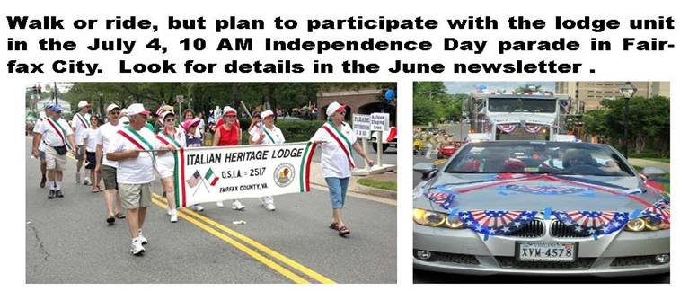

---------------------------------------------------------------------------------------------------

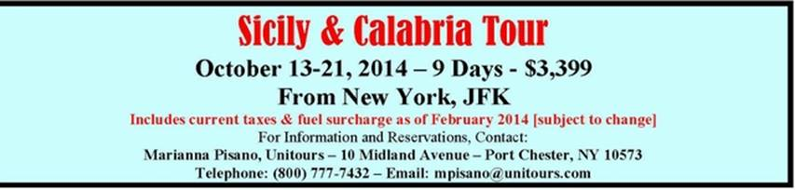
Room remains for you and yours. For more information, email
joe.lamarca@italianheritagelodge.org or phone Joe at 703-475-6962

ITALIAN WORDS AND PHRASES

Italian drill in space

Da poco la sonda Rosetta ha cominciato ad avvicinarsi alla cometa 67/P Churyumov-Gerasimenko, che dovrebbe raggiungere in agosto, e in novembre il lander Philae si separerà dalla sonda per scendere sulla superficie della cometa e perforarne il suolo.

Lanciata verso la cometa il 2 marzo 2004, è stata riattivata dopo un periodo di ibernazione iniziato l’8 giugno 2011. In questi dieci anni, Rosetta, progettata e costruita dalla di Airbus Defence and Space, ha seguito una lunga traiettoria interplanetaria che l’ha portata oltre l’orbita di Giove.
Rosetta è il primo veicolo spaziale della storia destinato ad atterrare su una cometa a 430 milioni di chilometri dalla terra per studiarla da vicino. È una pietra miliare per l’esplorazione spaziale, ma questa volta la bandiera da piantare sarà italiana. Amalia Ercoli Finzi, del politecnico di Milano, è la scienziata che ha ideato lo strumento destinato a trapanare la cometa, un oggetto cosmico oblungo di dimensioni stimate 2x4 chilometri.
In tutta la missione la presenza dell’Italia è importantissima. L’Italia ha concepito e finanziato diversi strumenti e in particolare quello che scende sulla cometa è uno solo: l’Sd2 realizzato dal politecnico di Milano e da Selex-Galileo e concepito per entrare nel cuore della cometa e analizzare le sostanze chimiche che la compongono.

Recently the probe Rosetta began to approach the comet 67/P that it should reach in August, and in November the lander, Philae, will separate from the probe to descend on the comet surface and drill into its terrain.

Launched toward the comet March 2, 2004, it was reactivated after a long period of hibernation which started on June 8, 2011. In these 10 years, Rosetta, designed and built by the Airbus Defence Space, followed along an interplanetary trajectory that brought it beyond Jupiter’s orbit.

Rosetta is the first space vehicle in history intended to land on a comet 430 million Km from earth to study it up close. It is a milestone for space exploration, but this time the Italian flag will be planted. Amalia Ercoli Finzi of the engineering school of Milan is the scientist that devised the instrument intended to drill the comet, an oblong object estimated at 2 x 4 km.

In the entire mission, the presence of Italy is very important. Italy designed and financed several instruments and in particular the one that will descend on the comet is one only; the Sd2, built by the engineering school of Milan and by Selex-Galileo, is designed to enter into the heart of the comet and analyze the chemical composition.

From: Betsy Mignani



