

APRIL 2015

PRESIDENT’S MESSAGE

Cari amici,

On Sunday, March 1, 2015, we officially installed our new officers at the Ft. Myer Officers Club. A buffet brunch preceded the installation ceremony. About 25 IHL members, their families and guests braved the unfortunately poor weather conditions to attend the ceremony. Those who did manage to attend were treated to an outstanding buffet lunch with an omelet and pasta bar and a carving station with turkey and a steamship round of beef along with an array of breakfast and lunch offerings. Generous servings of champagne were also available to those who wanted to partake. The ceremony itself went off without a hitch thanks to the stalwart efforts of IHL member, John Asiello. I personally want to thank the returning officers for their continued service to the IHL and to the newly installed officers who will serve on the IHL board for the coming year. Without the dedication of these individuals, the IHL could not continue as a viable organization.

Our upcoming events have changed slightly from those that were previously announced. On April 11, 2015, IHL members will enjoy a catered dinner, which is being planned by Gene La Colla. We do this once a year as a change from our usual pot-luck dinners. Everyone seems to enjoy the break from food preparation. Also, our bingo night will be postponed to later in the year. Instead, we will have any new members introduce themselves and provide some stories regarding their Italian ancestry. Anyone else who wishes to share something of their family history is also welcome to participate. These stories are sometimes humorous but always interesting as we share our common heritage.
On May 9, 2015, Joseph Scafetta, Jr., will present a discussion entitled "The Fifth Voyage of Columbus." We will also have a traditional pot-luck dinner that evening. Saturday, June 13, 2015, will feature bocce at my home. (Hopefully it should warm up by then). Further details for these events are contained in this newsletter or will be sent out separately.

We have some additional gift certificates left over from our Casino Night. We will put them up for auction at future events. We still have OSIA pins for any new member who has not received one. There are still many new members who have yet to receive their pin, and we will have them available again at upcoming events.

Broken record time! Perhaps one of our new members would be willing to step up here and take on this responsibility. Paul will assist you during any transition period including how to construct and edit the newsletter. PLEASE HELP! We are still looking for a replacement editor for the newsletter as Paul is stepping down after some ten years in that position. If you would like to serve your lodge in that capacity or know someone who may want to do it, please email me at delillo1@verizon.net or call me at 703-354-2454.

A Presto,

Dennis

ITALIAN HERITAGE LODGE 2517 – OFFICERS

President Dennis Lillo Lodge Trustees
703 354 2454 Delillo1(at)Verizon.Net Rosalie Ciccotelli----John Ingargiola
Vice-President Nicolette Sciscilo Marianne Hallihan----Anthony Musco
703 368 8922 Colette.Sciscilo(at)gmail.com Jeff Sciscilo
Imm Past-President Frank Marcinkowski Master/Mistress of Ceremonies
703 323 8447 Fmarcinkow(at)Verizon.net Walter Dougherty
Orator Dot Saia Renee Signorelli
703 978 8499 Dmjcs(at)Cox.Net Sentinel ---- Sal Guli
Recording Secy Eleanor Lillo Membership Chair:
703 354 2454 Delillo1(at)Verizon.Net John Asiello (jfasiello(at)AOL.Com)
Financial Secy Jo Lowe 703 321 7840
Lowejs(at)aol.com Education Chair:
Treasurer Laura Strong Lucio D’Andrea (ldandrea1933(at)
703 942 6323 Strong104(at)live.com Comcast.net)
Publicity Chair: Joe La Marca Member on the Grand Lodge:
703 455 0376 Jlamarca(at)erols.com John Asiello, Trustee

La Bandiera Editor:

Paul Alligood, 703 848 1758 – Palli14145@AOL.Com, 1908 Youngblood St., McLean, Va. 22101

Visit our lodge website at WWW.ITALIANHERITAGELODGE.ORG. Check the website for breaking news between newsletter editions.

SAVE THE DATES - FUTURE LODGE EVENTS

April 11 Lodge Meeting 6:00 P. M. At K of C (Catered Dinner)

April 15 Lunch Bunch 12:00 Noon Fortune Chinese Restaurant

April 15 Council Meeting 7:00 P. M. George Mason Library

April 25 Language Group 6:00 P. M. At the Ognibene’s

May 9 Lodge Meeting (Speaker) 6:30 P. M. At K of C (Men Cook)

June 13 Bocce at Lillo’s TBA



LODGE ANNOUNCEMENTS

The language group will meet April 25 at 6:00 P. M. at the Ognibene’s. Please advise Carlo & Betsy which food items you plan to bring.

MARK YOUR CALENDAR!!!
Your lodge needs you to walk or ride as part of our unit in this our ninth consecutive appearance in the City of Fairfax Independence Day Parade on the Fourth of July. Anyone who appreciates the Italian-American traditions is welcome to join, so please tell your family, friends, and neighbors to mark their calendars, too! Details will appear in later newsletter editions, but if you have any questions beforehand, contact joe.lamarca@italianheritagelodge.org.

APRIL BIRTHDAYS

Susan Bonsiero Apr. 3 Neil Nappo Apr. 19
Carlo Mignani Apr. 3 Vincent Serafino Apr. 20
Kathleen Ognibene Apr. 11 Fred Ingham Apr. 29
Marianne Hallahan Apr. 15 Frank Marcinkowski Jr. Apr. 29



APRIL ANNIVERSARIES

Joseph & Renee Signorelli April 5
Armando & Elisabetta Lazarte April 12
Jeffrey & Sharon Hayman April 16

APRIL LUNCH BUNCH

The Lunch Bunch will meet at noon on Wednesday, April 15, 2015, at the Fortune Chinese Restaurant located at Seven Corners Center, 6249 Arlington Blvd., Falls Church, VA. Their lunch of Dim Sum is famous throughout the area. They feature over 100 different Dim Sum choices from the carts that come by your table for your viewing and eating pleasure. You pay by the number of choices you make so that will be totally up to you and your appetite. I recommend you come hungry as this is a truly unique dining experience. Please let Dennis know if you plan to attend so he can include you in the reservation. Call at 703 354 2454 or email Dennis at delillo1@verizon.net.

LODGE MEETING – APRIL 11

Our lodge meeting on Saturday, April 11, at 6:00 PM will be catered by Tony’s NY Pizza. The cost is $15.00 per adult and $10.00 for children 10 and under. Please contact Gene La Colla for reservations at 703 246 9464 or gino4one@aol.com.

ITALIAN WORDS AND PHRASES

LA Repubblica Romana - da 509 a.C. a 27 a.C.

Questa forma di governo è durata 500 anni con poteri divisi che si bilanciavano ed elezioni ogni anno. Le cariche erano spesso collegiali e se composte da 2 individui, ognuno aveva il diritto di veto. Volevano che le deliberazioni non esprimessero i capricci individuali, ma fossero ponderate e prese nell’interesse comune: Res Pubblica o repubblica. I padri fondatori americani erano avidi lettori dei classici latini e hanno scritto la costituzione americana basandosi anche sui 500 anni d’ esperienza dell’antica Roma repubblicana. Parole come constitution, president, Congress, Senate, representative, executive, legislature, assembly, judiciary, vote, veto, candidate, election, states, plebiscite e tante altre nella vita politica, sono derivate dal latino. Anche Campidoglio e padri fondatori.

The Roman Republic – from 509 BCE – 27 AD

This form of government lasted 500 years with divided powers that were balanced and elections every year. The positions were frequently held by more than one individual, and when composed of two persons, each had the right of veto. They wanted the deliberations to not express individual whims but to be pondered and taken in the interest of the people: Res Pubblica means the thing of the state, or republic. The American founding fathers were avid readers of the Latin classics and wrote the constitution basing it also on the 500 years of experience of the ancient Roman republic. Words like constitution, president, congress, senate, representative, executive, legislature, assembly, judiciary, vote, veto, candidate, election, states, plebiscite and many others in political life are derived from Latin. Even Capitol Hill and founding fathers.

From Betsy & Carlo Mignani

Besides listening to interesting guest speakers and doing charitable activities, there’s more fun to be had at the Italian Heritage Lodge. Are you participating?

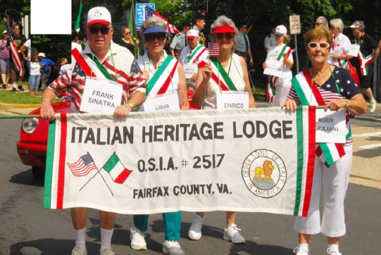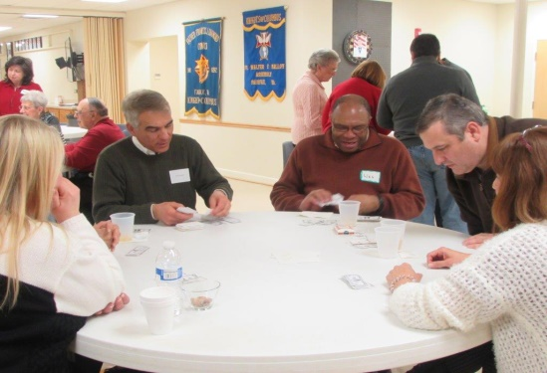
Independence Day Parades Casino Nights
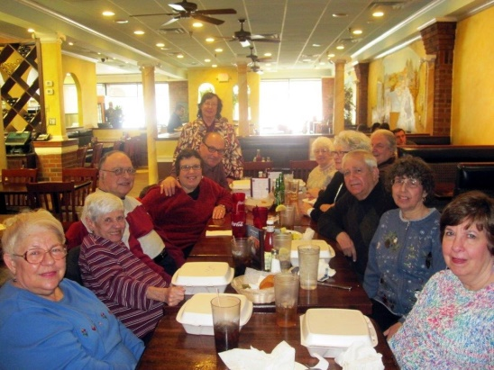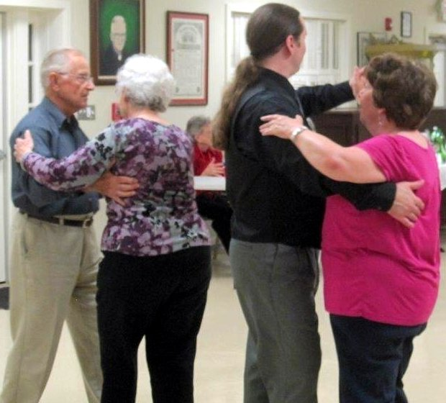
Lunch Bunches Dancing
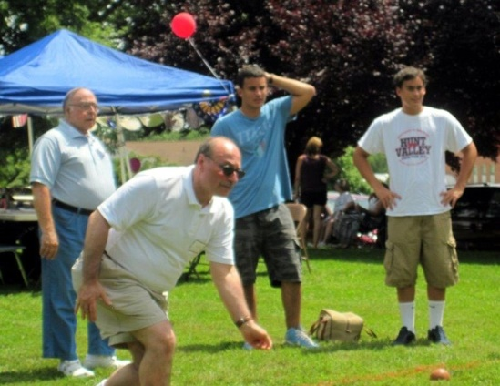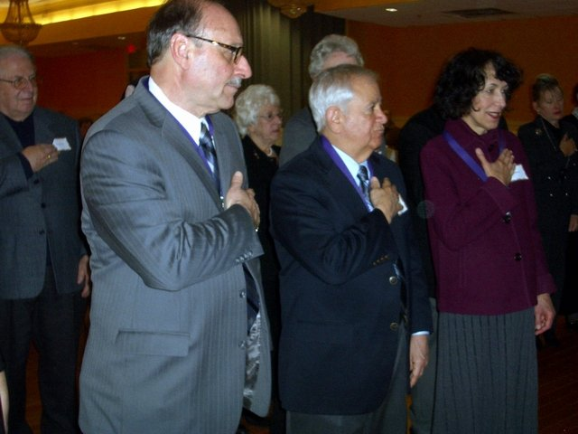
Picnics Officer Installation Ceremonies
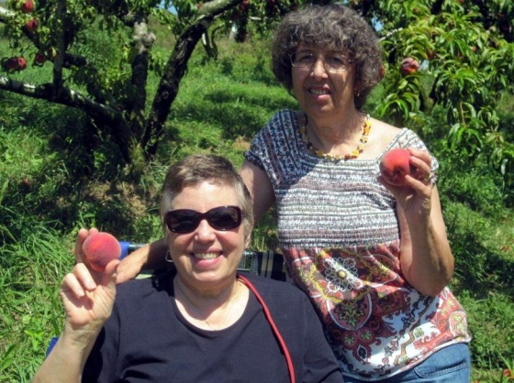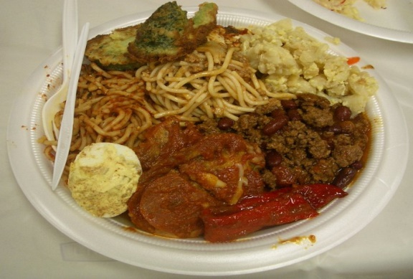
Peach Picking Pot Luck General Membership Mtgs



