

MAY 2007

PRESIDENT’S MESSAGE

Cara Amici,

Happy Mother’s Day to all the mothers and grandmothers.

Spring has finally arrived along with the budding trees, flowers and pollen. I hope that not too many of you are bothered with the running noses and eyes. Remember, this is bringing us into the wonderful summertime.

There is a lot going on in the lodge in the next several months. Read the inside of the newsletter for more information on each event:

May 12 is Casino Night – come and bring your friends and favorite finger food. This is a fund raiser for the lodge. Since it is Mother’s Day, there will be a flower for each of the ladies present.

May 19 is Preakness day – another fund raiser. There is still room on the bus for more “ushers” so give me a call and sign up for a fun day.

May 27 – Sunday – is Viva Vienna. We will have a booth to inform people of our organization. Volunteers are needed.

The deadline for the Grand Lodge Scholarship is May 15. Contact Jo Nunnenkamp for more info (703 893 4720).

All convention monies must be in by May 21. Get your reservations in for the Saturday night banquet by May 21.

Fraternally,

DOT

AMELIA HOGG

1921-2007

Your wit and wisdom

Will long be remembered

ITALIAN HERITAGE LODGE 2517 - OFFICERS

President Dot Saia Lodge Trustees
703 978 8499 dmjcs@Cox.Net Janine Andriole -- Bob Maida
Vice-President Joe LaMarca Joe Ganci -- Phil Traina
703 475 6962 Jlamarca@Erols.Com Yolanda Pelosi
Imm Past President Omero Sabatini Master/Mistress of Ceremonies
703 931 5054 Sabakiko72@Comcast.Net John Dovel
Orator Frank Marcinkowski Sr. Ivana Ganci
703 323 8447 FMarcinkow@AOL.Com Sentinel – Victor Haburchak
Recording Secy Dolores Marcinkowski Membership Chair:
703 323 8447 FMarcinkow@AOL.Com Bob Maida (Bob631@AOL.com)
Financial Secy Jo Lowe Members on the Grand Lodge
703 449 0682 Lowejs@AOL.Com Jo Vidiri Nunnenkamp – 1st V-P
Treasurer Gene LaColla 703 893 4270
703 246 9464 Gino4one@AOL.Com John Asiello, Trustee (703 321 7840)
JFAsiello@AOL.Com

La Bandiera Editor:

Paul Alligood, 703 848 1758 - Palli14145@AOL.Com, 1908 Youngblood St., McLean, Va. 22101

Visit our lodge website at WWW.ITALIANHERITAGELODGE.ORG (upper case added for emphasis – not required on the address line). Check the website for breaking news between newsletter editions.

FUTURE LODGE EVENTS

May 12 Lodge Meeting 7:00PM At K of C (Casino Night)

May 16 Council Meeting 7:00PM Fairfax Library

May 19 Trip To Preakness 6:30AM Leave From St. Luke’s Church (McLean)

June 9 Lodge Meeting 7:00PM At K of C

June 20 Council Meeting 7:00PM Fairfax Library

CASINO NIGHT – MAY 12

The general membership meeting this month will be “Casino Night” on May 12 (see flyer on Page 5). Winners at the game tables will receive prizes donated by lodge members and businesses who wish to support our charities. Therefore, it is important for all of us to see if we can procure gift certificates from restaurants, stores and business establishments that we patronize to be awarded as prizes. Otherwise, please bring a gift/prize from home. You can use the flyer when requesting gift certificates.


LODGE ANNOUNCEMENTS

The LUNCH BUNCH will meet Thursday, May 17, at noon at the Marco Polo Restaurant in Vienna. The fare is a buffet for $12.00 + tax and tip. Come one come all! Call Joe Saia (703 978 8499) for directions and reservations.

The Italian Cultural Society of Washington holds its social meetings at 3PM on Sundays at the Friendship Heights Village Center, 4433 South Park Ave., Chevy Chase, Md. You can call the Society for further details at 301 656 2797.

Check the website, italianheritagelodge.org. It now has pictures and is updated frequently.

MAY BIRTHDAYS

Giulio Porta May 2 David Strong May 21
Frank Marcinkowski, Sr. May 4 John Dovel May 23
June La Marca May 10 Elisa Mansuino May 23
Carl Malm May 10 Yolanda Pelosi May 26
John Asiello May 17



MAY ANNIVERSARIES

Gene & Carol LaColla May 15
Kevin & Teresa Brady May 23
Anthony & Corrine Marasco May 26
Jerry & Julie DiCerbo May 28

BOWLING


Our next bowling event will be Sunday, May 6, at BowlAmerica at Fairfax Circle. All bowlers and non-bowlers are welcome. This is bowling together for fun, not competition. Bring the kids and grand kids. For more information, contact Joe La Marca at 703 475 6962 or e-mail Joe at jlamarca@erols.com.

ITALIAN LANGUAGE LEARNING GROUP MEETING

The next meeting of our combined Italian language conversation group will be at 6PM on Saturday, May 5, at the home of Peter and Kathleen Ognibene, 509 Pendleton St., Alexandria. As always, all are welcome regardless of Italian language proficiency. Please contact Betsy Mignani, mignani@cox.net, 703 830 7699, and let her know which food item you plan to bring for the meal. Directions to the meeting site can be provided.

CONCERNS AND PRAYERS


Millie Malm

Marge Finocchiaro

Tricia Marcinkowski

CONVENTION

June 22 and 23 are only a few months away. The deadline for registering is May 22; the form is in the newsletter and is also available on the website. Saturday night will be the banquet-dinner dance which will include the awarding of the scholarships, presentation of the state awards and the Walter Junger Award, and the installation of officers. We are anticipating the installation of our own Josephine Nunnenkamp as the next Virginia state president. Wouldn’t it be wonderful to fill the room with IHL members to witness this grand event and to offer congratulations? If you are only attending the banquet, the cost is $55.00. You need to fill out a registration form and send it to Jerry Hyatt with the notation “Banquet Only” by May 22. Advanced reservations are required. Each lodge is requested to contribute a basket containing articles valued at $75 to $100 to be raffled on Saturday night. Tickets are 3/$2.00 or 10/$5.00. We will be selling tickets up until the time of the drawing. Once a name is drawn, it will be returned to the hopper so you have more than one chance of winning. Our basket will be an “Angel” basket – Susan Agosta is donating one of her famous Italian angels. All baskets will also include wine.

FUND RAISING

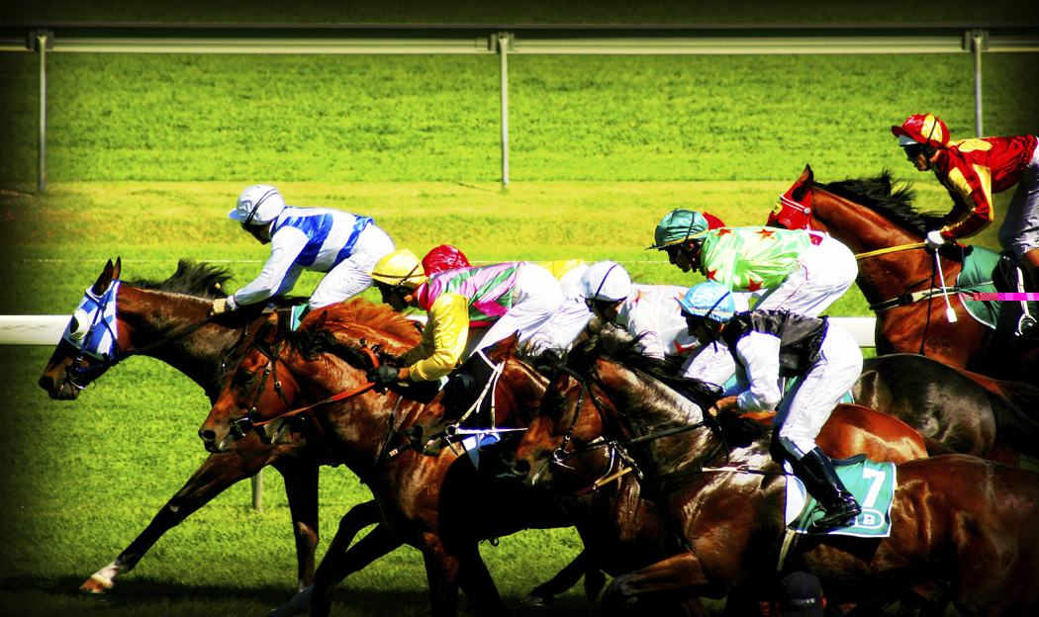
Come spend a fun-filled day on May 19 USHERING AT THE PREAKNESS to support the lodge. $50.00 is earned by the lodge for each person who participates. We are transported by bus from St. Luke’s Church in McLean to Baltimore, stationed at an inside area protected from the elements, provided a tasty box lunch and returned to the church. You will have an opportunity to place your personal bets on the horses and have a great view of the races. What could be easier – no traffic hassles, no parking problems and you meet a lot of nice people. We leave the church at 6:30AM and return in the early evening. Contact Dot if you’re interested. You must be 18 years of age.

The new supply of lodge hats are in and are going for the low price of $15.00. You will need one for the July 4th parade. We are also selling raffle tickets for the baskets to be raffled off at the convention; they will be available at all lodge functions between now and then.

CHARITY EVENT:

Sponsored by the

Italian Heritage Lodge #2517

Enjoy yourself at our next fun time

“CASINO NIGHT”

Saturday May 12, 2007

Join us and have a great time playing our variation of CASINO games: Stud Poker, Over & Under, Black Jack, Beat the Dealer and more.

REMEMBER WE USE “PLAY MONEY” AND WINNERS GET GIFTS DONATED BY MEMBERS AND LOCAL BUSINESSES.

This is a “wine and cheese” fare, so bring your favorite hors d’oeuvres, finger food, crackers, cheese bits and a favorite dessert.
The lodge will have wine, soda, beer, coffee, hot chocolate, etc.

Where: K of C Hall behind St. Leo’s Church on Old Lee Hwy, Fairfax

Time: 7:00 PM to 7:30 PM (social) and then the fun begins.

Admission: $5.00 donation for play money.

Charities: Proceeds support our charities such as Alzheimer’s, Cooley’s Anemia and Local Scholarships Programs.

PLEASE COME AND BRING A FRIEND

WHY I LOVE MOM

Mom and dad were watching TV when mom said, “I’m tired, and it’s getting late. I think I’ll go to bed.”

She went to the kitchen to make sandwiches for the next day’s lunches. Rinsed out the popcorn bowls, took meat out of the freezer for supper the following evening, checked the cereal box levels, filled the sugar container, put spoons and bowls on the table and started the coffee pot for brewing the next morning.

She then put some wet clothes in the dryer, put a load of clothes into the washer, ironed a shirt and secured a loose button.

She picked up the game pieces left on the table, put the phone back on the charger and put the telephone book into the drawer.

She watered the plants, emptied a wastebasket and hung up a towel to dry.

She yawned and stretched and headed for the bathroom. She stopped by the desk and wrote a note to the teacher, counted out some cash for the field trip and pulled a text book out from hiding under the chair.

She signed a birthday card for a friend, addressed and stamped the envelope and wrote a quick note for the grocery store. She put both near her purse.

Mom then washed her face with 3 in 1 cleanser, put on her night solution and age fighting moisturizer, brushed and flossed her teeth and filed her nails.

Dad called out, “I thought you were going to bed.”

“I’m on my way,” she said.

She put some water into the dog’s dish and put the cat outside, then made sure the doors were locked and the patio light was on.

She looked in on each of the kids and turned out their bedside lamps and TVs, hung up a shirt, threw some dirty socks into the hamper and had a brief conversation with the one up still doing homework.

In her own room, she set the alarm, laid out clothing for the next day and straightened up the shoe rack. She added three things to her six most important “things to do” list. She said her prayers and visualized the accomplishment of her goals.

About that time, dad turned off the TV and announced to no one in particular, “I’m going to bed.”

And he did…without another thought.

Author: Unknown



Grand Lodge of Virginia
Order Sons of Italy in America
Registration Form

Name: _____________________________________________________________

Address: ___________________________________________________________

City: ___________________________ State: ________ Zip Code: ____________

Telephone #: _____________________ E-mail Address: ____________________

Lodge: _____________________________________________________________

Arrival Date: _______________________ Amount Enclosed: _______________

Dietary Restrictions: _________________________________________________

The registration fee for the 2007 Biennial Grand Convention is $130.00 per delegate or guest. This fee includes the Friday Night Hospitality Suite (June 22nd), Breakfast and Lunch on Saturday plus the Banquet Dinner-Dance on Saturday Evening (June 23rd).
All checks must be made payable to the Grand Lodge of Virginia, and mailed to Jerry Hyatt, 5352 Sir Barton Drive, Virginia Beach, VA 23462. All fees must be received by May 21, 2007.

Hotel Information

Holiday Inn Tyson’s Corner
1960 Chain Bridge Road
McLean, Virginia

Telephone: 703-893-2100
Toll-free reservations: 1-800-HOLIDAY

Please notify the reservations agent that you are with the Sons of Italy Convention.
The hotel rate is $84.00 per room per night plus tax.
This rate is also available for those delegates arriving on Thursday, June 21st.
The reservation deadline is May 22, 2007. After this date, the rate is $189.00 per night plus tax.



