

DECEMBER 2012

PRESIDENT’S MESSAGE

Buon Natale! Christmas time in Italy is rich with traditions. One of the oldest and most cherished is the presepe or Nativity scene initiated by St. Francis of Assisi on Christmas Eve in 1223. Today, every city and town, every church, and almost every family home recreate the night of Jesus’ birth with figurines of Mary, Joseph, and Baby Jesus in the stable along with the shepherds, animals, and the Three Kings. Figures of townspeople such as the wine merchant, the laundress, the grocer, the baker, and many more are typically also included. Many towns have large exhibits of many different Nativity scenes lovingly crafted over the year by local artisans. When my daughter and I visited southern Italy at Christmas time two years ago, a highlight of our trip was seeing all the gorgeous Nativity scenes in Salerno, Lecce, and Matera. Typically, families will set up their presepe on December 8, the Feast of the Immaculate Conception. Every night before Christmas, they will gather by the Nativity scene to light candles and pray and sing hymns together. A week before Christmas, children dress as shepherds, and go from house to house in their neighborhood playing songs on shepherds’ pipes, singing carols, and reciting poems. They receive money to buy food and gifts for Christmas. Also, during the period before Christmas, musical programs are performed at churches dedicated to the Virgin Mary. The singers then visit the homes of local carpenters and sing hymns to honor St. Joseph.
Visiting with family and friends and feasting on special dishes and sweets is a special part of the holiday for Italians. Italian children write letters to their parents telling them how much they love them. The children place the letters under their father’s plate at Christmas Eve dinner and they are read after the meal. The traditional Italian Christmas dinner is called Cenone and consists of spaghetti, lasagna, or cannelloni, anchovies, fresh broccoli, fish, fruits, and tossed salads. These are accompanied with cheese, fruits, and sweets soaked in red or w hite wine. Favorite Christmas sweets are torrone ( a white nougat candy with almonds), panettone, cassata, panforte,or pandoro.
The Urn of Fate is an old tradition in which family members take turns drawing presents out of a large, decorated bow. The ceppo is another old custom. It is a triangular wooden frame several feet high with several tiers of shelves with each shelf holding small gifts, fruit, or candy. Often a Nativity scene is placed on the bottom shelf. The ceppo is entirely covered with colored paper, gilt pine cones, and miniature colored pennants. Small candles are fastened to the sides; a star or small doll is placed at the apex of the triangle.
Many families hang La Befana dolls astride a broomstick in their homes as a decoration. La Befana brings the children presents on the Epiphany on January 6. In some areas of southern Italy, the Christmas Angel brings presents to children; those who have been naughty find their stocking filled with a peach limb rather than toys and candy.
I wish you and your family a joyous Christmas. Please join us for our Christmas party on
December 22.

Anne

ITALIAN HERITAGE LODGE 2517 – OFFICERS

President Anne Marrelli Lodge Trustees
703 385 0814 Anne.Marrelli(at)gmail.com Sal Guli----Angelo Vecchio
Vice-President Fred Michaelangelo Tony Finocchiaro----Dennis Lillo
703 323 8294 AMichaelangelo(at)msn.com Art Moscatello
Imm Past-President Frank Marcinkowski Master/Mistress of Ceremonies
703 323 8447 FMarcinkow(at)Verizon.Net Kevin Brady
Orator Dot Saia Yolanda Pelosi
703 978 8499 Dmjcs(at)cox.net Sentinel ---- Paul Alligood
Recording Secy Eleanor Lillo Membership Chair:
703 354 2454 Delillo1(at)Verizon.Net John Asiello (jfasiello(at)AOL.Com)
Financial Secy Jo Lowe 703 321 7840
Lowejs(at)AOL.Com Education Chair:
Treasurer Gene La Colla Art Moscatello (ArthurMoscatello(at)
703 246 9464 Gino4one(at)AOL.Com Comcast.Net)
Members on the Grand Lodge Publicity Chair: Joe La Marca
Susan Agosta McFetridge – Trustee (Jlamarca(at)erols.com)
(smcfetridge(at)caci.com) 703 455 0376

La Bandiera Editor:

Paul Alligood, 703 848 1758 – Palli14145@AOL.Com, 1908 Youngblood St., McLean, Va. 22101

Visit our lodge website at WWW.ITALIANHERITAGELODGE.ORG. Check the website for breaking news between newsletter editions.

FUTURE LODGE EVENTS

No Council Meeting in December

Dec. 22 Christmas Party 6:00 PM At K of C

Jan. 8 Lunch Bunch 12:00 Piero’s

No Language Group meeting in December

Jan. 12 Lodge Meeting (Auction) 6:30 PM At K of C



LODGE ANNOUNCEMENTS

There is no council meeting or language group get-together in December.

..
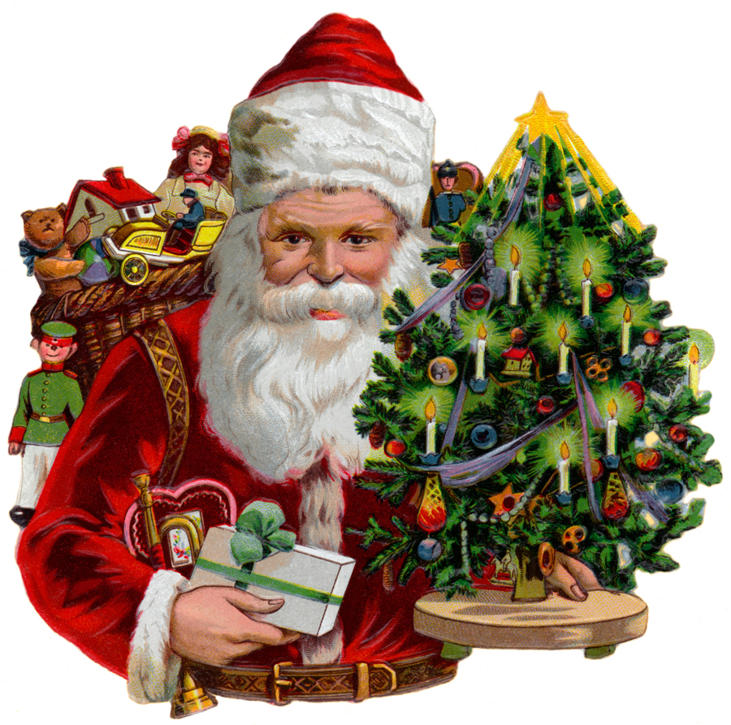
CHRISTMAS GENERAL MEMBERSHIP PARTY

This year’s Christmas party will be Saturday evening, December 22, 2012. Due to the extended length of the program and the young age of the primary audience, the social will begin at 6:00 PM. The program will include a visit from La Befana and presentation of the La Befana story. There will also be a guest from the North Pole.

IMPORTANT: It is especially important that you call in your reservation since Santa Claus will be making a surprise visit with a present for each child 12 and under. CHILDREN MUST BE PRESENT AT THE PARTY TO RECEIVE A GIFT. Members who are bringing children 12 and under are asked to call John or Laura Asiello at 703-321-7840 no later than December 18th to provide the name, gender, and age of the child, which will give Santa time to select a gift for each child.

The meal will be the traditional pot luck, with a focus on entrees or side dishes that will feed at least 6 to 8 people as there is usually a large turnout for this meeting. Anyone wanting to bring something additional can also bring a dessert or appetizer.

****SPECIAL NOTICE: Our annual tradition of our children giving a gift to the Hospital for Sick Children will not take place this year since the hospital will not receive gifts after December 18th. Our efforts to find another worthy organization did not materialize. The end result is that we will not be able to accept gifts in support of this program this year.

The younger attendees will have the opportunity to participate in the La Befana presentation. These members and guests are asked to bring their creative, dramatic, and oratorical energy—talent not required.

DECEMBER BIRTHDAYS

Rosalie Ciccotelli Dec. 2 Alex Cunningham Dec. 19
Rosaling Michaelangelo Dec. 5 Palmer DeMeo Dec. 19
Maria D’Aiello Dec. 6 Steven Lipton Dec. 21
Betsy Mignani Dec. 6 Alessandro Sacilotto Dec. 21
Frank Bonsiero Dec. 8 Augie Taormina Dec. 24

Peter Ognibene Dec. 9 Robert Borgatti Dec. 27

DECEMBER ANNIVERSARIES

NONE

JANUARY LUNCH BUNCH

The Lunch Bunch will meet at Noon on Tuesday, January 8, at Piero’s Restaurant in Fairfax.

LODGE ELECTION OF OFFICERS

The lodge will elect officers early next year for 2013-2014. The following timetable is set out in the lodge’s by-laws for election of officers:
Top of Form

November 2012 – The president appointed John Asiello, Dennis Lillo and Joe La Marca to comprise the nominations committee.

December 2012 - The chairman of the nominations committee shall report the nominations from the Committee. (No nominations are made from the floor at this meeting.)

January 2013 - Newsletter will carry the results of the nominations committee. Members may nominate from the floor at the January lodge meeting.

February 2013 - Elections are held. No more nominations are permitted except in case of withdrawal. 2013 being an odd number year, delegates to the state convention are also elected.

March - Newly elected officers are installed.
Bottom of Form

LODGE SHIRTS
At our last IHL meeting, we broached the idea of ordering shirts that would feature an American and Italian flag surrounded by the words “Italian Heritage Lodge”.
Dennis Lillo wore one as an example at the last meeting. It was a White knit, very durable short sleeve shirt with an embroidered emblem over the left pocket area as described above. The cost would be around $25 per shirt (cost could come down depending on the number of shirts ordered). We will be taking orders at our next IHL meeting, the Christmas party on December 22nd, at the Knights of Columbus hall behind St. Leo’s.

Sponsors for “Casino Night Fundraiser” November 10, 2012

We want to thank our sponsors for their contributions to the success of this fundraiser and assure them that 100% of moneys collected go directly to Alzheimer’s disease, Cooley’s anemia, Autism and Local Scholarships, our targeted charities for this year.

Please patronize our sponsors listed below and thank them for making our charitable event a huge success:

Ariana Grill and Kabob, 6920-H Bradlick Shopping Center, Annandale, VA 22003
Burke Town Nails, 9560 Old Keene Mill Road, Burke, VA 22015
Domino’s Pizza, 8962 Burke Lake Road, Springfield, VA 22151
Express Shoe Repair, 7048 Columbia Pike, Annandale, VA 22003
Flower Den, 6960-T Bradlick Shopping Center, Annandale, VA 22003
Giant Foods
Hunan West, 8938 Burke Lake Road, Springfield, VA 22151
Kilroy’s, 5250-A Port Royal Road, Springfield, VA 22151
Little Italy Bar and Grill, 6920-J Bradlick Shopping Center, Annandale, VA 22003
Martial Arts, 5230-B Port Royal Road, Springfield, VA 22151
Milano’s Family Restaurant, 6230-G Rolling Road, Springfield, VA 22152
Monty’s Steak House, 8426 Old Keene Mill Road, Springfield, VA 22152
P. J. Skidoos, 9908 Fairfax Blvd, Fairfax, VA 22030
Papa John’s Pizza, 6228 Rolling Road, Springfield, VA 22152
Pane e Vino, 9020 Lorton Station Blvd, Lorton, VA 22079
San Vito RistoranteItaliano, 8944 Burke Lake Road, Springfield, VA 22151
Silverado, 7052 Columbia Pike, Annandale, VA 22003
Swiss Bakery, 5524 Port Royal Road, Springfield, VA 22151
Szechuan Star Restaurant, 6960-H Bradlick Shopping Center, Annandale, VA 22003



